Title of the Paper
ABSTRACT
This manuscript template provides the standard structure and formatting styles for Original Scientific Papers and Preliminary Communications. Each section is associated with a predefined style available in Word’s Styles menu. Review Papers may follow a more flexible structure, while the required sections for Data Papers are specified separately in the Guidelines for Authors. Authors are encouraged to use and adapt this template for Review Papers and Data Papers while maintaining the predefined formatting styles. During manuscript preparation, any sections that are not applicable should be removed. The abstract should provide a clear and structured summary of the study and should not exceed 400 words. It must briefly state the research context and objectives, outline the materials and methods, summarise the key results, and highlight the main conclusions. The abstract should be written as a single paragraph, should not include references, and the use of abbreviations should be kept to a minimum.
Keywords: keyword1; keyword2; keyword3; keyword4; keyword5; keyword6; keyword7 (Four to seven keywords reflecting the main topics of the paper and supporting indexing and discoverability. Keywords should preferably differ from words used in the title.)
INTRODUCTION
The introduction should clearly define the aims and significance of the study and place it in the context of existing research. Relevant literature should be cited to outline the current state of knowledge, but extensive or unnecessary literature reviews should be avoided.
In-text citations should be placed in parentheses and before punctuation marks. Authors are encouraged to avoid citing non-scientific literature (e.g. legislation, regulations, web pages) whenever possible. If necessary, sources such as personal communications, regulations, or unpublished works should be mentioned only in the text, preferably in parentheses, and not included in the reference list.
Citations should include the author’s family name followed by the year of publication (James 2018). For publications with two authors, both authors' family names should be given (James and Smith 2018). For publications with more than two authors, only the first author’s family name should be followed by et al. (James et al. 2018). Publications by the same author(s) published in the same year should be distinguished by lowercase letters (James 2018a, 2018b). Multiple citations within the same parentheses should be listed in chronological order and separated by commas (James et al. 2018a, 2018b, Brown 2019, Smith 2019).
See the end of the document for more details on references.
MATERIALS AND METHODS
This section should describe the study design, materials, and methods in sufficient detail to allow reproducibility. Novel methods should be described in detail, while established methods may be cited. Subsections (e.g. Study Area, Data Collection, Statistical Analysis) may be used where appropriate.
Figures and Tables (This is Subsection)
Figures (photographs, graphs, diagrams, schematic drawings, etc.) and Tables should be inserted into the main text close to their first citation and must be numbered following their number of appearances (Figure 1, Figure 2, Table 1, Table 2, etc.).
Figures (This is Subsubsection)
Figures (photographs, graphs, diagrams, schematic drawings, etc.) should be placed in the manuscript close to their first citation and numbered consecutively (Figure 1, Figure 2, etc.).
In addition to figures embedded in the manuscript, all figure files must be uploaded separately during submission as a single ZIP archive. Figures should have a minimum resolution of 300 dpi. Common file formats are accepted; TIFF and JPEG are preferred.
Figure captions should appear below the figure and clearly describe its content. Legends should be concise and may be placed inside or below the figure where appropriate.
Both colour and black-and-white figures are acceptable. Diagrams and graphs should be presented on a white background. Consistent symbols, line styles, and colours should be used for the same variables throughout the manuscript.
If figures are reproduced or adapted from other sources, the original source must be clearly cited, and authors are responsible for obtaining permission from the copyright holder.
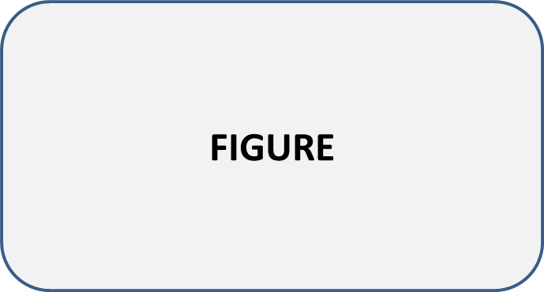
Figure 1. Title of the figure.
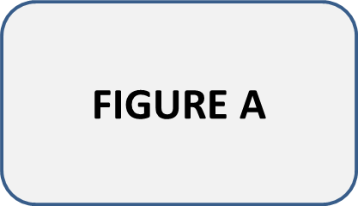 | 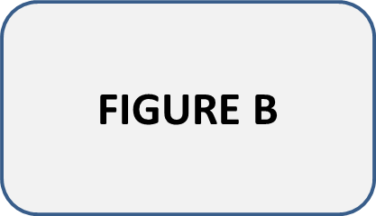
(a) | (b)
Figure 2. Title of the figure. If there are multiple panels, please provide a description for each panel, e.g.: (a) Description of the first panel; (b) Description of the second panel.
Tables (This is Subsubsection)
Table captions should appear above the table and clearly describe its contents. Column headings should be concise and, where necessary, explained using abbreviations defined in the caption or in a table legend placed below the table.
Numerical values should use decimal points (e.g. 2.53). The use of colour in tables should be avoided; only table headings may be shaded (grey). For large tables, use a smaller font, but no smaller than 8 pt.
If tables are reproduced or adapted from other sources, the original source must be clearly cited, and authors are responsible for obtaining permission from the copyright holder.
Table 1. Title of the table.
Subcompartment | Area  (ha) | Basal area  (m²·ha⁻¹) | Volume  (m³·ha⁻¹)
5a | 4.2 | 22.7 | 154.1
5b | 3.0 | 23.8 | 203.2
10a | 5.4 | 24.7 | 241.1
10b | 5.1 | 25.4 | 278.4
Table 2. Title of the table.
Research area | Tree species | Results
Research area | Tree species | Δ±SD  (m) | RMSE  (m) | R²
Norway | Picea abies, Pinus sylvestris | -0.18±3.15 | n/a | 0.75
UK | Deciduous | -1.27 | n/a | n/a
Canada | Pseudotsuga menziesii | -1.32±0.81 | n/a | 0.84
Finland | P. sylvestris | -0.65±0.49 | n/a | 0.99
Switzerland | P. montana, P. cembra | n/a | 0.6 | 0.92
Idaho, USA | Coniferous | -1.07 | 2.64 | 0.94
Sweden | Deciduous | -1.20±6.40 | n/a | n/a
Δ – mean difference between tree heights derived from Lidar and by terrestrial measurement; SD – standard deviation; RMSE – root mean square error; R² – coefficient of determination; n/a – not available
Bulleting and Numbering
Bulleted lists look like this:
- First,
- Second,
- Third.
Numbered lists look like this:
- First,
- Second,
- Third.
Equations
This is an example of an equation (Equation 1):
y = β₀ + β₁·x | (1)
where y is dependent variable, x is dependent variable, and β₀, β₁ are parameters.
Equations should be written clearly and numbered consecutively in parentheses on the right-hand side. Simple equations may be included directly in the text. Complex equations should be created using Microsoft Equation Editor (MS Office 2007 or later) or MathType. Equations must be editable and should not be submitted as images. In the text, equations should be referred to as Equation 1, Equation 2, etc.
Units
The International System of Units (SI) must be used. Non-SI units should be converted to SI units where possible. All symbols, Greek letters, and special characters must be clearly defined.
Exponential notation should be used for units rather than slashes. Examples: m; m²; m³·ha⁻¹; µmol·m⁻²·s⁻¹, etc.
Monetary values should be expressed in euros (preferred) or US dollars. If another currency is used in the original data, it must be converted to euros, using the exchange rate valid at the time of data collection. The date of conversion (at least month and year) should be provided.
Scientific Names
Scientific names of plants, animals, and microorganisms should be written in italics. The author citation of scientific names should be provided only at the first occurrence in the abstract and main text, but not in the title (e.g. Quercus robur L., Abies alba Mill.).
When common names are used, the corresponding scientific name should be given at first mention.
Abbreviations and Footnotes
Abbreviations and acronyms should be defined at first use in the text and introduced only if the term appears three or more times.
Footnotes should not be used.
RESULTS
Results should be presented clearly and concisely, without interpretation. Redundant presentation of the same results in both tables and figures should be avoided. The Results and Discussion sections may be combined only if scientifically justified.
DISCUSSION
The discussion should interpret and contextualize the results, explain their significance, and relate them to previous studies. Results should not be repeated. Limitations and implications may be addressed where relevant.
CONCLUSIONS
This section is mandatory. Conclusions should be presented clearly and succinctly, highlighting the main findings that directly arise from the results. No new data or interpretations should be introduced.
Appendix A
This section is optional. Contains additional material that supports the main text but is not essential for understanding the core results (e.g. detailed tables, extended methodological descriptions, or supplementary analyses). Appendices are included within the manuscript file after the Conclusions section and referenced in the main text where appropriate. All appendices must be cited in the main text and labelled using capital letters, starting with Appendix A (e.g. Figure A1, Figure A2, Table A1, Table A2).
Table A1. Title of the table.
Figure A1. Title of the figure.
Appendix B
Table A2. Title of the table.
Figure A2. Title of the figure.
REFERENCES
All references cited in the text, including those cited in tables and figures, must be listed in the reference list in alphabetical order. The reference list should include only works cited in the manuscript that have been published or formally accepted for publication. Authors must follow the reference formatting instructions exactly, as deviations may result in delays in the publication process. A Digital Object Identifier (DOI) should be provided for all references where available. Journal titles should be abbreviated according to ISO 4 standards, using the Journal Title Abbreviations provided by Web of Science.
Lastname FM, Lastname FM, Lastname FM, Year. Title of the paper. Abbreviated Journal Name Volume(Issue): Firstpage-lastpage. doi (if available).
Lastname FM, Lastname FM, Lastname FM, Year. Title of the paper. In: Lastname FM, Lastname FM (eds) Title of Collected Work (if available) or Proceedings of the Name of the Conference, Location of Conference, Country, Date of Conference. Publisher, City, Country, Firstpage-lastpage.
Lastname FM, Lastname FM, Year. Title of the Book. Edition. Publisher, City, Country, Pages. doi (if available).
Lastname FM, Lastname FM, Year. Title of the Chapter. In: Lastname FM, Lastname FM (eds) Title of the Book. Edition. Publisher, City, Country, Firstpage-lastpage. doi (if available).
Lastname FM, Year. Title of the Thesis. Type of Thesis (PhD or MSc Thesis), Faculty, City, Country, Pages.
Lastname FM, Lastname FM, Lastname FM, Year. Title of the paper in online non-scientific magazine. Journal Abbreviation (if available) or full Journal name Volume(Issue): Firstpage-lastpage. (if available). Available online: URL (Date of accessing).
Lastname FM of Authors or Institution (preferably abbreviation), Year. Title of the manual or report. Institution (publisher), City, Country, Page range. Available online: URL (Date of accessing).
Title of Site, Year (if applicable). Title of the Topic (if applicable). Available online: URL (Date of accessing).
SUPPLEMENTARY FILES
Supplementary files may be uploaded in any file format during Step Four of the online submission process (Open Journal System). Files should be named consecutively as Suppl. File 1, Suppl. File 2, etc. Supplementary materials must be explicitly referenced in the manuscript using the corresponding file name (e.g. Supplementary File 1: Dataset 1). When supplementary files are provided, authors should include in the manuscript a brief description of each file, including file name, file format, title, and a short description. Supplementary materials are not displayed within the final article, but are made available online via direct links to the files supplied by the authors. If supplementary material is provided, please list the information about the materials here.
File name:
File format:
Title:
Description of Data:

File name:
File format:
Title:
Description of Data:

